**Objective**

Build Android Packages using Unity

**Findings**

* You need...
  + the correct JDK version
  + the correct Android NDK version
  + the correct Android SDK version
* In Unity, you navigate to Preferences (With my version is it under the Edit drop down menu)

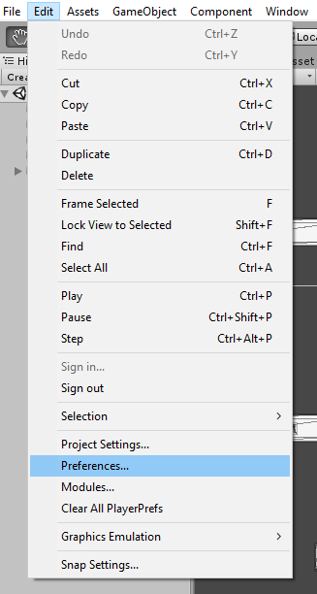

* + Next, select External Tools on the left side of the Preferences window

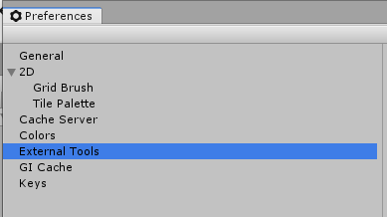

* + FInally, on the right side of the window, after selecting External Tools, you add the paths to the Android SDK, NDK and JDK.

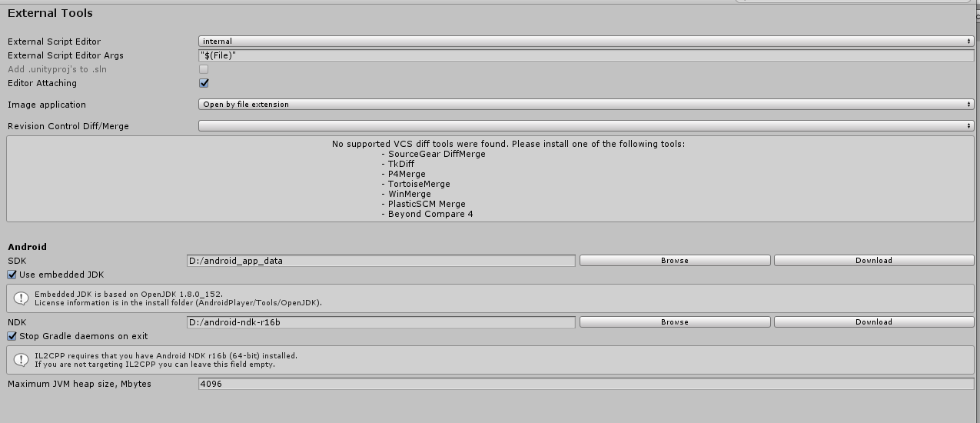

* When you are ready to build your project…
  + Go to File>Build Settings…

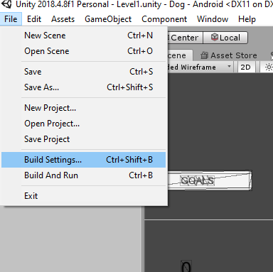

* + In the popup window, select the platform you want to build for. In this case, Android.

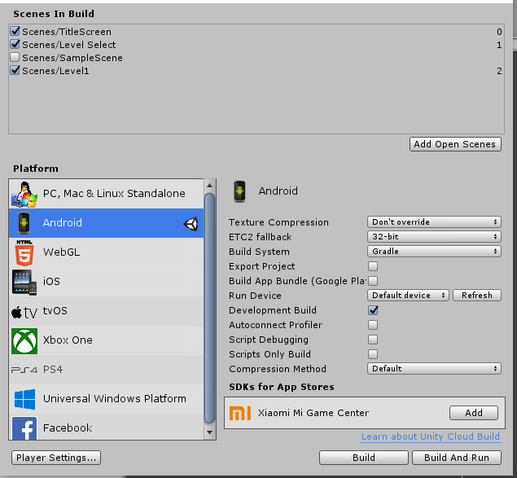

* + After selecting Android, click the Switch Platform Button. (No SS available atm)
  + Now select the Player Settings Button.
  + Follow the instructions in this [video](https://www.youtube.com/watch?v=btynG9O8zRw).
  + The video will walk you through signing your project. This is required to build the apk.
  + After following the instructions in the video, you should now be able to click the build button, name the package and save.

**Conclusion**

It works but there is a lot going on that I do not really understand. Why the local keystore? How to secure the keystore? Anything malicious that can be done if my keystore is compromised?